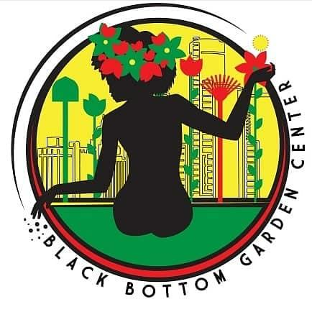

The Black Bottom Garden Center is a for-profit co-op founded and led by four Black women in Detroit’s North End. The center operates as an LLC at Oakland Avenue Urban Farm. The group participated in the Detroit Community Wealth Fund’s (DCWF) North End Co-op Academy and Incubator, a 16-week program launched during COVID in 2020. The garden center grew out of existing friendships and community and arose out of the brainstorming of what businesses residents wanted to see in their community. The name, Black Bottom, references the fertile Black soil that so easily grew things [in the former Black Bottom community], but also in reference to the thriving Black businesses that existed there before the freeway was built through it and took them away. As they navigate inequities for Black-women owned businesses and struggle to attain resources, they affirm common co-op principles of monetary investment and sweat equity carrying the same weight. They are on the journey of identifying the true business partners, developing trust and care with each other, developing standard operating procedures and overall growing the businesses according to their vision of making all customers “Black Bottom Happy.” They currently sell garden items such as seeds, garden starter plants, houseplants, compost, custom blend potting soils, planting pots, and cultivation tools. Some challenges they have experienced include: identifying competitors through market research, organizing around personal lives, leveraging Black buying power and developing Standard Operating Procedures (SOP) and financial tracking mechanisms.

